Lucas LED Street Lights

Designed and developed

By

U-Tron (Beijing) Electronics Co Ltd.,

General Information

Installation Guide

Warranty

Version 1.47

Part Number:
U-6800-000-R2

Copyright 2008-2009 U-Tron (Beijing) Electronics Co. Ltd.,
Beijing, San Francisco, New York and Hong Kong.

Table of Contents
Table of Contents 2
About The Developers 3
Features and Benefits of U-Tron LED Lights 5
Lucas I 30 LED 6
L1 30 Technical Specifications: 6
L1 30 Packaging Information: 7
Lucas I 42 LED 8
LI 42 Technical Specifications: 8
LI 42 Packaging Information: 9
Lucas II 60 LED 10
L2 60 Technical Specifications: 10
L2 60 Packaging Information: 11
Lucas II 84 LED 12
L2 84 Technical Specifications: 12
L2 84 Packaging Information: 13
Lucas III 114 LED 14
L3 114 LED Technical Specifications 14
L3 114LED Packaging Information 15
LED Chips Features 16
Power Supply Technical Specifications: 18
U-Tron LED Drivers Error! Bookmark not defined.
Boost Type Drivers: Part # U-6800-LIN Error! Bookmark not defined.
Boost Type Drivers Features Error! Bookmark not defined.
LT3003 Features Error! Bookmark not defined.
Buck Type Drivers: Part # U-6800-NSI 25
Theory of Operation 25
Buck Type Driver Features 26
Remote LED Arrays 27
Complete Lamp Assembly 28
Assembly Instructions 29
Lamp Post Installation: 30
Safety Bolt Installation: 31
Lamp Post (Light Pole) Recommendations: 32
Recommended Height and Pole-to-Pole distance: 32
Photo Controller: (optional) 33
JL-201C Technical specifications: 33
Photocell Installation Instructions 34
Photocell Socket wiring 34
Protection Hood Cover: (optional) 35
Bird Wire: (optional) 35
Dimming Controller: (optional) 36
Power Line wiring: 37
Warranty 38

About The Developers

Please visit www.u-tron.com

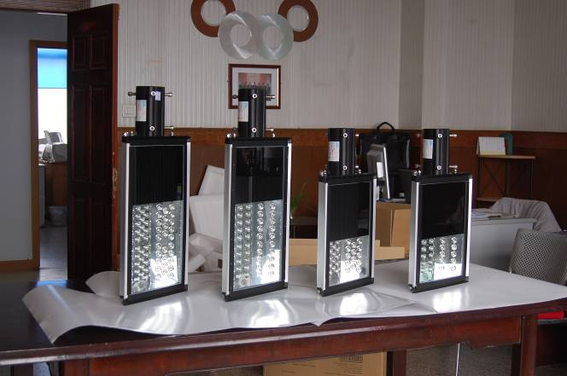

Features and Benefits of U-Tron LED Lights

- The right product for the application. LEDs today output the illumination necessary to protect our streets, our sky, and our environment.
- The LEAST costly alternative available today. LED Street Lights deliver the best economic return compared to conventional alternatives considering the total life-cycle costs including installation, maintenance and energy.
- Consume less energy. Generally, a LED consumes less than 0.1 watts. This low power consumption means you save on your energy costs.
- No heat output, less CO₂ pollution. LEDs can convert almost all the energy used into light creating a highly efficient light source. In contrast, the alternative conventional lighting technologies emit heat energy and/or light pollution.
- Long lifetime. A LED can last up to 100,000 hours. High Power LEDs can last up to 50,000 hours. In comparison the lifetime of an incandescent light is about 1,000 hours and that for a halogen light is about 2,000 hours.
- Environmentally safe. LEDs are made from non-toxic materials unlike fluorescent lights which contain mercury. Plus LED lights can also be recycled.
- Durable. No loose or moving parts. Can withstand extreme temperatures. High Impact Resistance, Shock-proof. No filaments and no glass envelopes, means no breakages: unlike traditional lamps .No ultraviolet (UV) or infrared (IR) radiation to harm the human body
- Easy on the eyes. No strobe effect: eliminates the visual fatigue which is caused by the strobe effect of the traditional street lamps
- Dark-sky Friendly. Brings back the stars for us and for the other creatures of this planet.
- No Cleaning Necessary. No burned insects accumulate on the surface area, so no reduction in brightness: unlike conventional lamps.

Lucas I 30 LED
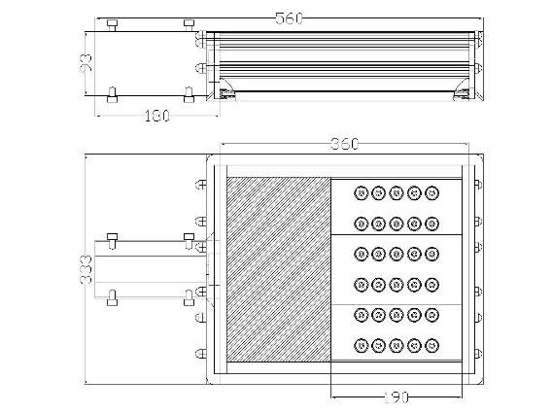
Figure 1 Lucas 1 30

L1 30 Technical Specifications:

Number of LEDs 30
Total Power Consumption 40 watts
LED Type Cree Q2
Total LED Consumption: 34 watts
Power Rating: 220V 50Hz
Power Supply Consumption: 6W
Temperature rating: -40 ºC to 45 ºC
Maximum Operating Temperature <50ºC (Open Air)
LED Initial Flux: 2,610 lm
LED Maintain: 2,558 lm
IP Rating: IP 65
Light Dimensions: 560x333x100.50mm

Warranty on Workmanship 36 Months
Guarantee on LED < 50% loss 60 Months or
(Which ever comes first) 50,000 Hrs

L1 30 Packaging Information:

Net Weight: 8.71 Kg
Gross Weight 11.07 Kg
Carton Size (1 Pc/carton): 640x400x200mm

Container | Number of Pieces
20 foot | 561
40 foot | 1,166
40 foot HQ | 1,378
Table 1

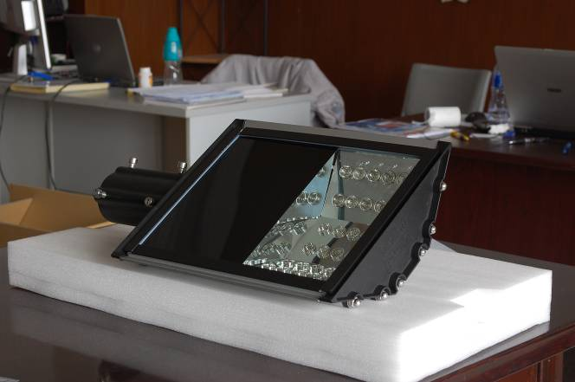
Figure 2 Lucas I 30 LED Street Light

Lucas I 42 LED

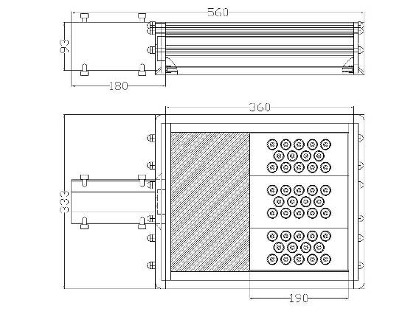
Figure 3 Lucas I 42 LED Street Light

LI 42 Technical Specifications:

Number of LEDs 42
Total Power Consumption 55 watts
LED Type Cree Q2
Total LED Consumption: 48.51 watts
Power Rating: 220V 50Hz
Power Supply Consumption: 7W
Temperature rating: -40 ºC to 45 ºC
Maximum Operating Temperature <50ºC (Open Air)
LED Initial Flux: 3,654lm
LED Maintain: 3,300 lm
IP Rating: IP 65
Light Dimensions: 560x333x100.50mm

Warranty on Workmanship 36 Months
Guarantee on LED < 50% loss 60 Months or
(Which ever comes first) 50,000 Hrs

LI 42 Packaging Information:

Net Weight: 8.71 Kg
Gross Weight 11.07 Kg
Carton Size (1 Pc/carton): 640x400x200mm

Container | Number of Pieces
20 foot | 561
40 foot | 1,166
40 foot HQ | 1,378
Table 2

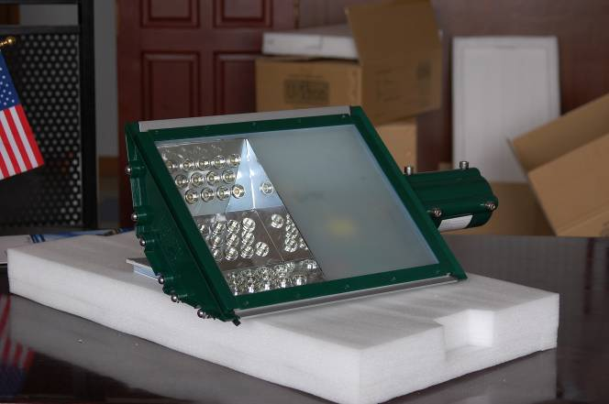
Figure 4 Lucas I 42 LED Street Light

Lucas II 60 LED

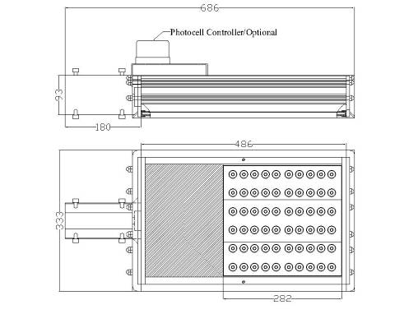
Figure 5

L2 60 Technical Specifications:

Number of LEDs 60
Total Power Consumption 80 watts
LED Type Cree Q2
Total LED Consumption: 69.3 watts
Power Rating: 220V 50Hz
Power Supply Consumption: 10.5W
Temperature rating: -40 ºC to 45 ºC
Maximum Operating Temperature <50ºC (Open Air)
LED Initial Flux: 5,220 lm
LED Maintain: 4,989 lm
IP Rating: IP 65
Light Dimensions: 689x333x100.50mm

Warranty on Workmanship 36 Months
Guarantee on LED < 50% loss 60 Months or
(Which ever comes first) 50,000 Hrs

L2 60 Packaging Information:

Net Weight: 11.0 Kg
Gross Weight 13.77 Kg
Carton Size (1 Pc/carton): 760x400x200mm

Container | Number of Pieces
20 foot | 561
40 foot | 1,166
40 foot HQ | 1,378
Table 3

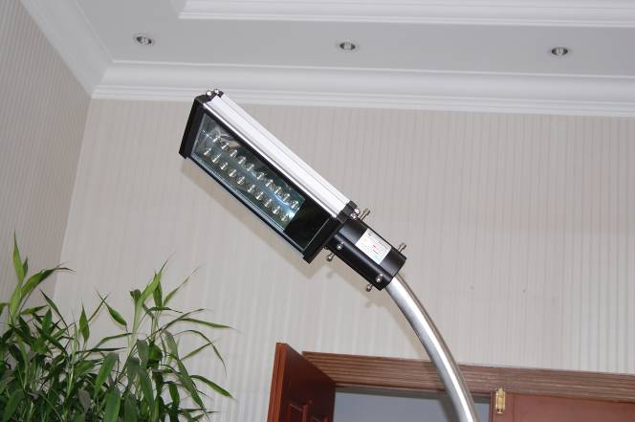
Figure 6 Lucas II 60 Watts (inside view)

Lucas II 84 LED
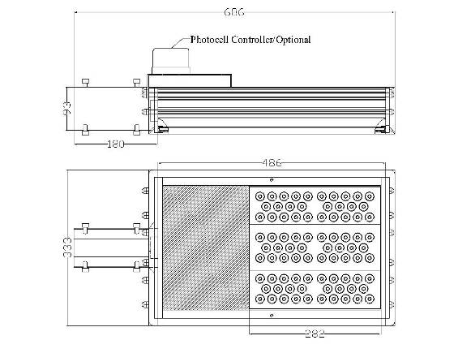
Figure 7

L2 84 Technical Specifications:

Number of LEDs 84
Total Power Consumption 110 watts
LED Type Cree Q2
Total LED Consumption: 96.6 watts
Power Rating: 220V 50Hz
Power Supply Consumption: 10.5W
Temperature rating: -40 ºC to 45 ºC
Maximum Operating Temperature <50ºC (Open Air)
LED Initial Flux: 7,308lm
LED Maintain: 7,200 lm
IP Rating: IP 65
Light Dimensions: 689x333x100.50mm

Warranty on Workmanship 36 Months
Guarantee on LED < 50% loss 60 Months or
(Which ever comes first) 50,000 Hrs

L2 84 Packaging Information:

Net Weight: 11.0 Kg
Gross Weight 13.77 Kg
Carton Size (1 Pc/carton): 760x400x200mm

Container | Number of Pieces
20 foot | 561
40 foot | 1,166
40 foot HQ | 1,378

Table 4

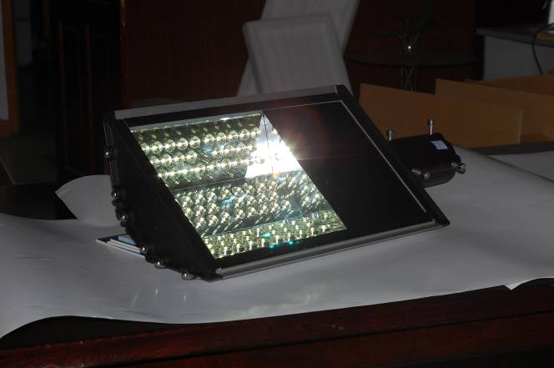

Figure 8 Lucas II 84 LED

Lucas III 114 LED
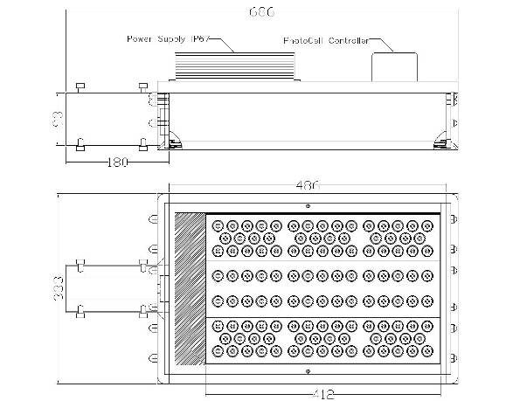

L3 114 LED Technical Specifications

Number of LEDs 114
LED Type Cree Q2
Total LED Consumption: 131 Watts
Total Power Consumption: 135 Watts
Power Rating: 220V 50Hz
Temperature rating: -40 ºC to 45 ºC
Maximum Operating Temperature <50ºC (Open Air)
LED Initial Flux: 9,918 lm
IP Rating: IP 65
Light Dimensions: 689x333x100.50mm
Warranty on Workmanship 36 Months
Guarantee on LED < 50% loss 60 Months or
(Which ever comes first) 50,000 Hrs

L3 114LED Packaging Information
Net Weight: 15.0 Kg
Gross Weight 17.5Kg
Carton Size (1 Pc/carton): 760x400x200mm

Container | Number of Pieces
20 Foot | 561
40 Foot | 1,166
40 Foot HQ | 1,378

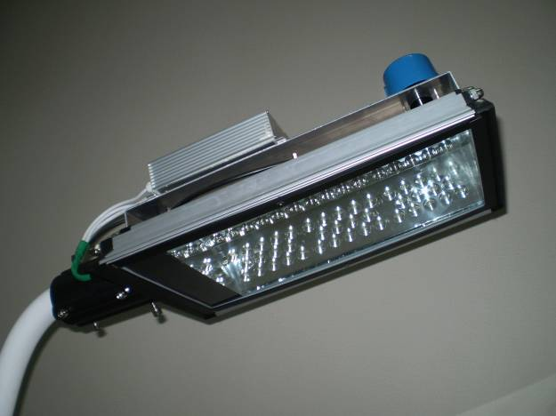
Lucas III 114 LED

LED Chips Features

- Guaranteed minimum flux order codes up to107 lm
- Available in white (2,600 K to 10,000 K CCT),
- Drive current: 350mA to 1000 mA
- Industry’s lowest thermal resistance: 8°C/W
- Max junction temperature: 150°C
- Industry-leading JEDEC standard prequalification testing
- Reflow solderable – JEDEC J-STD-020C compatible
- Electrically neutral thermal path
- RoHS-compliant
- Lumen maintenance of greater than 70% after 50,000 hours

U-Tron Street Lights can be ordered for 3 kinds of light source: Cool White, Natural White and Warm White. See Figure 3 below:

Color and Temp Range | Cree Part Number | Lumens | U-Tron Ordering Part Number
Cool White  5,000 K  10,000 K | P4 | 80.6 | 6800-CP4-CW
Cool White  5,000 K  10,000 K | Q2 | 87.4 | 6800-CQ2-CW
Cool White  5,000 K  10,000 K | Q3 | 93.9 | 6800-CQ3-CW
Cool White  5,000 K  10,000 K | Q4 | 100 | 6800-CQ4-CW
Cool White  5,000 K  10,000 K | Q5 | 107 | 6800-CQ5-CW
Neutral White  3,700 K  5,000 K | N3 | 56.8 | 6800-CN3-NW
Neutral White  3,700 K  5,000 K | N4 | 62.0 | 6800-CN4-NW
Neutral White  3,700 K  5,000 K | P2 | 67.2 | 6800-CP2-NW
Neutral White  3,700 K  5,000 K | P3 | 73.9 | 6800-CP3-NW
Neutral White  3,700 K  5,000 K | P4 | 80.6 | 6800-CP4-NW
Warm White  2,600 K  3,700 K | N2 | 51.7 | 6800-CN2-WW
Warm White  2,600 K  3,700 K | N3 | 56.8 | 6800-CN3-WW
Warm White  2,600 K  3,700 K | N4 | 62.0 | 6800-CN4-WW
Warm White  2,600 K  3,700 K | P2 | 67.2 | 6800-CP2-WW
Warm White  2,600 K  3,700 K | P3 | 73.9 | 6800-CP3-WW

Table 5

Notes:
Cree maintains a tolerance of +/- 7% on flux and power measurements.
Typical CRI for Cool White & Neutral White (3,700 K – 10,000 K CCT) is 75.
Typical CRI for Warm White (2,600 K – 3,700 K CCT) is 80.

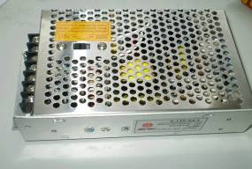
Power Supply Technical Specifications:
Figure 9
Depending on the size of your lamp, the power supply used may vary in size and input voltage. Extreme care has to be taken when changing or repairing the power supply. Unauthorized personal should NOT try to repair the power supply for safety reasons.

AC/DC power supplies are out-sourced from professional power supply manufactures. Very strict quality control measurements are applied by the companies who manufacture the power supplies to our specifications. When calling us for service please makes sure you have the serial number of the lamp handy. The serial number enables us to identify which power supply is installed in the lamp. Please do not attempt to replace the power supply with generic AC/DC converters. LED lights are very different from the conventional Lamps in the following aspects:
High initial Currents
Very small footprint
Efficient Heat Transfer (Using conventional method)
MTBF over 100,000Hrs.
OEM Manufacturer: Chengilian
Type I uses: CL-C-70 and Type II uses: CL-C-120
Power Supply Consumption: Type I: 7W Type II: 10W
AC input voltage range: 90-132V AC for Taiwan, Japan, USA and Northern America
176-264V AC for Europe and the rest of the world
Input frequency: 47-63Hz
Output adjustment range: V1:±5%
Output overload protection: 110-150%i
Output over-voltage protection: 115-150%
Withstand voltage: I/P-O/P:3KV AC/1min and I/P-F/G:1.5KV AC/1min
Rise time: 50ms
Hold up time: 20ms
Working temperature:-10~+50°C
Storage temperature: -20~+85°C
Safety standards: design refers to GB4943.UL60950.EN60950
EMC standards: design refers to GB9254.EN55022 class A
MTBF :> 100,000hours

U-Tron LED Drivers
U-Tron provides 2 types of driver boards for different LED Lights applications. One is the Boost type and its best suited for Solar Powered units (battery and solar panel). The other one is a Buck type and its better suited for high voltage AC Applications. Both have the same foot print and mounting brackets. Boost type can be also used for regular power supplies found in the market.
Many power supplies found in the market can’t with stand the life cycle expected by the LED lamps. The high quality power supplies that can be guaranteed for 50,000 hours may be very expensive. U-Tron driver boards take your worries away from you. We have designed the Driver boards with proven technology to give 50,000 hours MTBF. This is to match the LEDs that can be found in the market today. When a power supply fails you don’t have to replace the driver boards or the LEDs. All you need to do is to replace the
power supply.
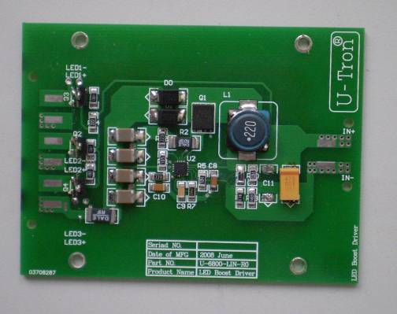
Figure 10
U-Tron Boost Drive PCB Board
Pin 1 and 2
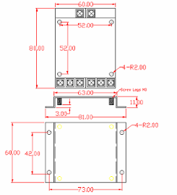

Figure 11
PCB Board Dimensions
Applies to Buck and Boost configurations:

Pin assignments:
Pin 1 – Input DC +
Pin 2 – Input DC – Ground
Pin 3, 5 and 7 – Output DC + to LED Arrays
Pin 4, 6 and 8 – Output DC – Ground to LED Arrays

Boost Type Drivers: Part # U-6800-LIN

For driving the Standard LED U-Tron Lamp sets, we use the Linear Technology voltage regulator chips together with the 3003 splitter or array of similar transistors to divide the current in 3 equal amounts, The LT3755 is a DC/DC controller designed to operate as a constant-current source for driving high current LEDs. They drive a low side external N-channel power MOSFET from an internal regulated 7V supply. The ﬁxed frequency, current-mode architecture results in stable operation over a wide range of supply and output voltages. A ground referenced voltage FB pin serves as the input for several LED protection features, and also makes it possible for the converter to operate as a constant-voltage source. A frequency adjust pin allows the user to program the frequency from 100kHz to 1MHz to optimize efficiency, performance or external component size.

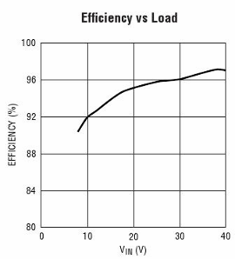
Figure 12

Boost Type Drivers Features
- 3000:1 True Color PWM Dimming
- Wide Input Voltage Range: 9V to 36V
- Output Voltage Up to 70V
- Constant-Current and Constant-Voltage Regulation
- 100mV High Side Current Sense
- Adjustable Frequency: 100kHz to 1MHz
- Programmable Under voltage Lockout with Hysteresis
- Open LED Status Pin (LT3755)
- Frequency Synchronization (LT3755-1)
- PWM Disconnect Switch Driver
- CTRL Pin Provides Analog Dimming
- Low Shutdown Current: <1μA
- Programmable Soft-Start

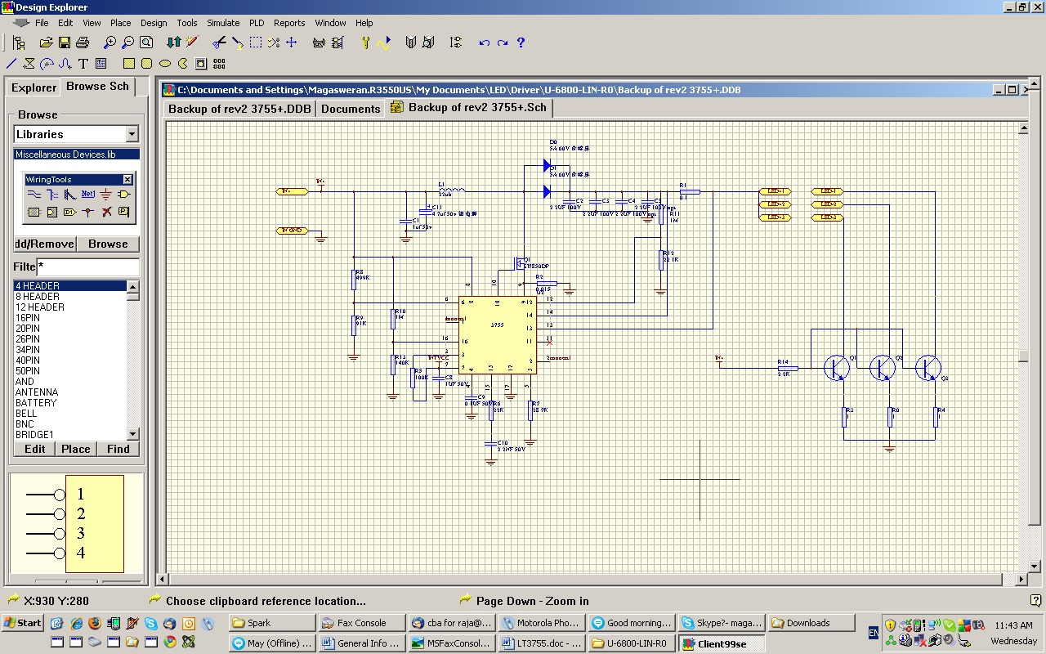

Please specify constant current value when ordering:

Figure 13
Circuit diagram
Ordering part number: 6800-LIN-R2

About the Voltage:

The input voltage can be anywhere between 9V DC to 36V DC
Output voltage can be anywhere between 12V DC to 70V DC.
However, you must operate this driver board in a boost environment.
Meaning, the input voltage must be lower than the output voltage. When connecting LED, make sure you have enough number of LEDs connected in a serial mode to exceed the input voltage. You can use the 3.5V as a guideline for the commercially available LEDs today.

For example: if your power source is a 12 V Batteries then the minimum number of LED you can connect in a serial mode must be more than 4 but less than 20.

If your power source is a 24 Power Supply then the minimum LEDs can’t be less than 8 but again must be less than 20.

About the constant current:

Our boards can be configured to a number of assortments of Constant Current configuration but this has to be done at the time of ordering.

In any event you cannot exceed the Maximum current of1 Amp. U-Tron driver boards are configured to produce 3 equal amounts of 333mA of 3 circuits for connecting 3 sets of parallel LED panels. Please note newer versions may have constant current selector of popular values.

Future Products:
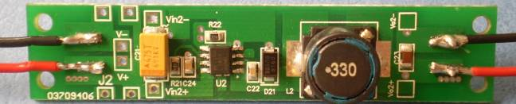
Our new 6800-LIN-SLIM is a slim design that’s gives customers a unique way of configuring the input and output requirements. You can choose 150, 250, 350, 500, 750, 1000 mA just by changing the jumper on the board.

Please note:
- Reverse polarity protection is not available in the older versions. Revision 1, 2 and 3. R4 and the rest will be equipped with the reverse polarity protection.
- Protective cover available upon request.

Buck Type Drivers: Part # U-6800-NSI

U-6800-NSI Buck driver boards are designed around the National Semiconductor LM3404HV regulator. U-Tron buck controller boards are designed to handle up to 3 circuits with a maximum of 10 high power LEDs each (total of 30 LEDs, U-6800-010 lamps and not suitable for the U-6800-014 LED lamp sets) This driver board can be configured to 1, 2 or 3 lamp sets. The LM3404 was chosen for this purpose and because the combination of high output current, high input voltage, and high duty cycle creates the greatest demand for low junction to ambient thermal resistance (θJA).

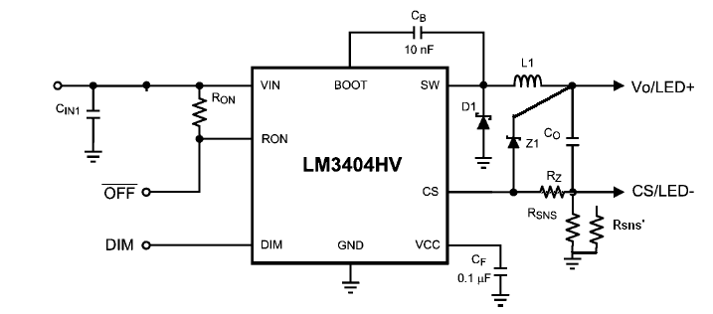
Figure 14
Buck Converter Current Loops

Theory of Operation

U-6800-NSI is a buck regulator with a wide input voltage range, low voltage reference, and a fast output enable/disable function. These features combine to make it ideal for use as a constant current source for LEDs with forward currents as high as 1.2A. (Note for U-Tron Lamps the current is set at 320 mA) The controlled on-time (COT) architecture is a combination of hysteretic mode control and a one-shot on-timer that varies inversely with input voltage. Hysteretic operation eliminates the need for small signal control loop compensation. When the converter runs in continuous conduction mode (CCM) the controlled on-time maintains a constant switching frequency over the range of input voltage. Fast transient response, PWM dimming, a low power shutdown mode, and simple output over voltage protection round out the functions of the LM3404HV.

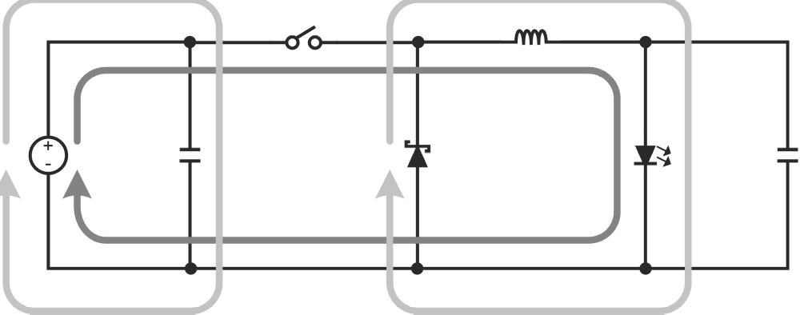

Figure 15
, Buck Converter Current Loops

Buck Type Driver Features

- Integrated 1.0A MOSFET
- VIN Range 6V to 42V (LM3404)
- VIN Range 6V to 75V (LM3404HV)
- 1.2A Output Current Over Temperature (designed for 330mA)
- Cycle-by-Cycle Current Limit
- No Control Loop Compensation Required
- Separate PWM Dimming and Low Power Shutdown.
- Supports all-ceramic output capacitors and capacitor-less outputs
- Thermal shutdown protection
- Package - PSOP-8
- Special Application guaranteed by Manufacture for 1.0A Constant Current Buck Regulator for Driving High Power LEDs

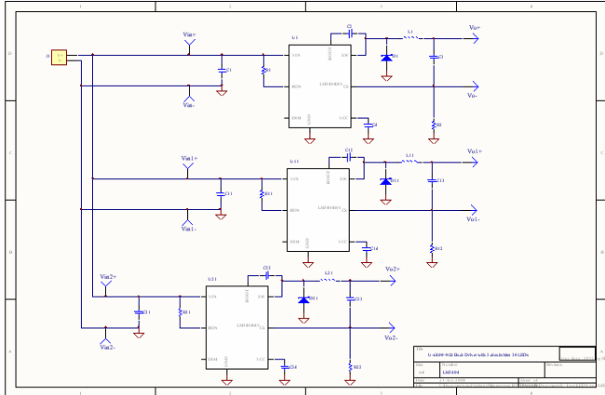

Figure 16
U-Tron Buck Driver Board
Circuit Diagram

Remote LED Arrays

In our LED Street Lamps LED arrays are separated from the Driver Boards by several inches. Because of this, the output capacitors C3, C13 and C23 are rated for AC impedance. Usually 100V is used to withstand the LED array parasitic inductance from the rest of the converter. The current sense resistor R1, R12 and R22 shall remain on the same PCB, close to the LM3404HV.

Complete Lamp Assembly
. 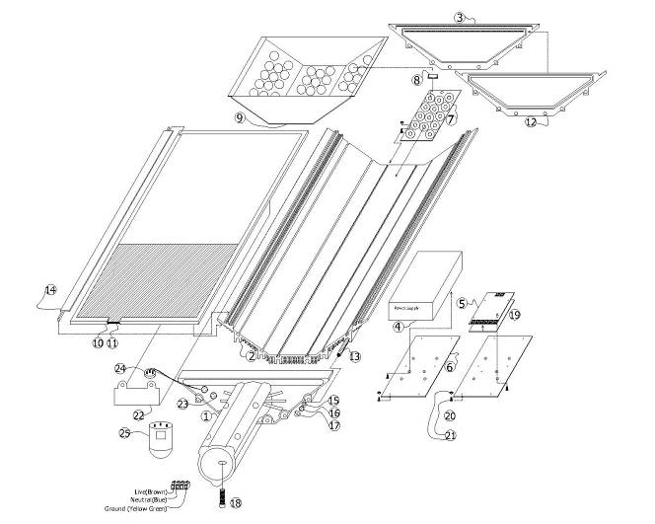
Figure 17
(Shown here is a 42 LED Lamp)

1 - Head | 6 – Power Supply Holder | 11 – Glass Cover | 16 – M8 Split Lock Washer | 21 – M3 Hex Nut
2 – Main Frame | 7 – LED Board | 12 - Gasket | 17 – M8 Cap Nut | 22 – Photocell Hood
3 - Tail | 8 – LED Caps | 13 – M8 Rod | 18 – M10 Socket Screw | 23 - Connector
4 – Power Supply | 9 – LED Caps Holder | 14 – Glass Holder | 19 – Heat Transfer Sole | 24 – Photocell Receptacle
5 – Driver Board | 10 – Glass Rubber | 15 – M8 Flat Washer | 20 – M3 Phillip Screw | 25 – Photocell

Assembly Instructions

Tools and consumable items required:
1. M3 Hex Wrench with narrow tip,
2. Soldering Iron
3. M8 Socket Wrench
4. M10 Allen Key
5. Phillips M3 Screwdriver
6. Drill and M3.5 Drill Bit
7. Thermal Conductivity Paste (“Heat Sink Grease”)

Precautions.
- Observe ESD precautions when handling driver boards. Use of a correctly earthed wrist strap is recommended.
- Wear latex gloves when handling the reflector cover to protect it from grease.
- Do not remove the protective film from the reflector until Step 17

Assembly Steps
- Place the inverted Main Frame on a soft surface (see Fig. 23).
- Apply a temporary label/serial number to the Mainframe ensuring that label is positioned where it will be legible after sub-assemblies are in place
- Apply Heat Sink Grease to Base Plate of Optical Sub-Assembly LED Board and insert OSALB into the grooves in the main frame and locate it in the correct place.
- Apply Heat Sink Grease to the Base Plate of the Driver Board – Insert Driver Board Base Plate into the grooves in the Main Frame.
- Lock the OSALB and Driver Board into place by tightening the hex nuts with the M3 hex wrench.
- Connect the wiring from driver board to the OSALB.
- If using Internal Power Supply Insert Power Supply Heat Transfer Sole into the grooves in the Main Frame and lock into place. If using External Power Supply go to step 10.
- Connect the wires coming from the Driver Board to the Power Supply.
- Power up Testing/QC – Connect the AC cord to the power supply and power up to check the lamp if is working. The quality controller will list the components that are mounted on the Main Frame. If everything is working disconnect the AC cord to the power supply.
- Position the Reflector Cover on the top of the OSALB.
- Insert the Threaded Rods through the holes in the main frame. NOTE if using an External Power Supply or Photo Cell the 2 center rods should be inserted later since they will be used to mount the Power Supply and Photo Cell Hood.
- Place the holes in the Tail over the ends of the Rod then fit the washers and M8 cap nut. NOTE ensure that a gasket is on the inside surface of the tail.
- If using an Internal Power Supply pass the Cable Cord through the Gland in the Head and connect to the power supply.
- If using a Photo Cell and/or an external Power Supply assemble on the Hood:
  - The Photo Cell is passed from the top through the round hole on the hood and is held in place using a screw from the top of the Photo Cell to the “U” shaped clamp which locates against the lower edge of the hood. (See detailed assembly instructions on Page 31 below.)
  - The External Power Supply is fixed to the top of the Hood using 4 bolts through mounting holes drilled in the Hood.
- Place the holes in the head over the ends of the Rods. NOTE ensure there is a gasket on the inside of the head.
- If using an Internal Power Supply connect the power cord from the head to an AC power source then light up the lamp.
  - If using a photocell or external power supply connect the wires from the socket to the Driver Board. Connect the Power Supply to an AC source then light up the lamp.
- Remove the protective film.
- Put the Glass on the top of the Main Frame. Ease the Glass Seal inside the flanges on the Main Frame (it may help to tilt the Glass slightly while doing this).
- Press the Glass firmly into place ensuring that it is pressed fully home.
- Place the 2 Glass Holders on the top of the Glass inserting them under the head and tail.
- Fix the Head and Tail securely against the Mainframe with nuts and washers.
- Lock each Glass Holder in place with an M3.5 screw through a hole drilled at the middle of the Glass Holder.
- If using a Photocell or External Power Supply fix the Lamp Hood to the Main Frame using nuts and washers on the two center rods.
- Burn and test for 24 hours.
- Put the serial number on the lamp
- Pack the finished lamp.

Lamp Post Installation:
Six M10 bolts are provided with each lamp. The uppermost bolt is used for safety purposes. Lucas Lamps are designed to fit the light post standards used in most countries. However, there are variations and our normal lamps may not fit the lamp posts used in some countries. Please contact us if special modifications are required. In general we support end of post diameters from 65 mm to 72 mm. (2 inch to 2 ¾ inches)

Use the M10 hex tool supplied with the lamp to tighten the 5 mounting bolts securely to the pole. The uppermost bolt h must go through the pole for safety reasons.

See below for details.

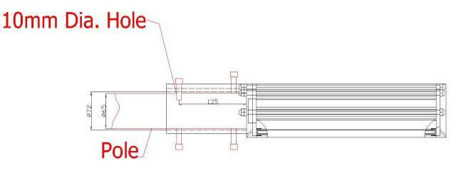

Safety Bolt Installation
Figure 18

Safety Bolt Installation:

On the upper side of the Lamp Post we recommend you drill a 10mm diameter hole about 135mm from the end of pole. This is to secure the lamp against falling off or sliding and twisting due to wind or other natural phenomena. See Figure 11 above.

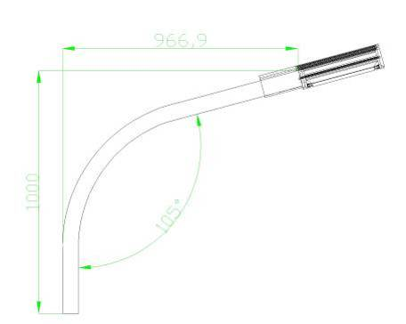

Recommended Upward Tilt On Lamp Post

Figure 19

Lamp Post (Light Pole) Recommendations:

Lucas Lights are designed for low height lamp posts. We recommend the lamp post to be tilted upwards at about 105° to obtain best results. See Figure 12 above.

Recommended Height and Pole-to-Pole distance:

Model # | Lucas I 30 | Lucas I 42 | Lucas II 60 | Lucas II 84
Pole Height | 4-5 meters | 5-6 meters | 6-7 meters | 7-8 meters
Pole-to-Pole distance | 10 - 15 meters | 15 - 20 meters | 20 - 25 meters | 25 - 30 meters

Figure 20

Photo Controller: (optional)

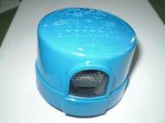
Figure 21

The optional 3rd party "Photo Control" (sold separately) turns the lamp on automatically at dusk and turns it off at dawn for added security and convenience.

JL-201C Technical specifications:
Easy-to-maintain Twist-lock (ANSI C136.10)
- IP65 protection while installed
- Easy-to-test Instant switching-over
- Multi-volts available
- Surge Arrester built-in
- UL & C-UL listed.
- SPST-NO
- Electromagnetic AC relay switching
- UV stabilized Polycarbonate cover & clear window
- High impact Polybutylene terephthalate Base
- 1” CdS photocell for standard; 1/2” CdS photocell with heat sink available
- 110J/3500A MOV for standard; 235J & 460J MOV available
On-Off Levels: 6Lx On(Dusk); 50Lx Off(Dawn);
While 220V: 3Lx On, 30Lx Off(JL-201C)
Ambient Temp.: -40℃ ~ +70℃
Related Humidity: 96%
Power consumption: 1.5VA Max.
Electrical Life: 5000 cycles

Photocell Installation Instructions

Install the supplied Twist Lock Socket into the hole on the hood and firmly attach the pin onto the bottom using the center screw. Ignore the 2 holes on the outer edge of the socket. Before tightening the center screw make sure the arrow is pointing to the north.
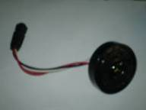
Figure 22
Twist Lock Socket

The other end of the socket has a 3 pin water proof connector which will plug into the head piece of the lamp where you will find a matching socket.

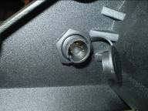

Figure 23
3 pin waterproof connector for Twist Lock Socket

Photocell Socket wiring

Wire #1 (3) – Black – Live
Wire #2 (5) – White – Neutral
Wire #3 (7) – Red – Load
(IP65 version Socket use the numbers inside parenthesis)

Now you can install the Photocell onto the twist Lock socket. Make sure you turn clockwise gently and secure firmly the photocell. Please read the operating voltage requirements before connecting to the power. See the user manual for power wiring instructions.

Our lamps will work well with Ripley 5732-S models in a 120V60Hz environment for most US cities. Other specifications are available on demand.

Protection Hood Cover: (optional)

This protector is to protect the lamp from weed growth and bird droppings. In some cities we have seen weeds can easily grow on top of our lamp head. Our LED lamp heads are designed with heat sinks, which need to be kept relatively clean to work efficiently. If the heat sinks accumulate dust over a long period, this can become fertile base for the weeds to grow. This problem results from the heat transfer function of the lamp head. Rain and snow will naturally remove dust and pollution but cannot remove weeds after they are well rooted into the lamp head. If this problem exists in your area we recommend using the Protection Hood cover. See photo below:

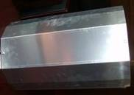
Figure 24

Bird Wire: (optional)

This option is very useful in cities where birds are found in large flocks. Pigeons often perch on top of the lamp heads and leave large amounts of droppings. This can affect the lamp head’s ability to radiate heat efficiently. If this option is installed lamp heads are no longer a desirable perch for birds: a humane solution that will not harm the birds.

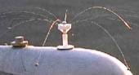

Figure 25

Dimming Controller: (optional)

The optional "Dimming” function is available with all U-Tron driver boards, however, it must be specified when placing the order. If desired please indicate at how many hours after lights are turned on, the dimming function should kick in and to what intensity (as a percentage) the light should dim. Please Note: This is not a field selectable option.

Power Line wiring:
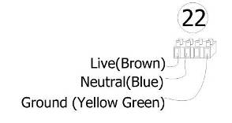

Power Line Installation Guide

Figure 26
Unless otherwise special ordered by the customer, a common 4 prong connector will be supplied with each light. Please refer to figure 14 above for wiring instructions. The ground wire is separated by one space for easy recognition. Live and Neutral are color coded to the EU standards, however, there may be variations depending on the country in which you install the lamp.

If the external flexible cable or cord of the lamp is damaged, it shall only be replaced by the manufacturer or its service agent or a similar qualified person to avoid danger and the risk of injury .

Warranty

U-Tron (Beijing) Electronics Co. Ltd., warrants the products listed below for a period of 36 months from the date of shipment to be free from defects in materials or workmanship and to be of the kind and quality designated or specified in the purchase agreement. If any product dose not meets the above warranty and the buyer promptly files a warranty claim U-Tron shall do the following:
U-Tron shall provide a 12 months “No Questions Asked” replacement of any faulty units at no charge to the customer. The time limit for exchange shall not exceed 30 days from the time a claim is filed by the buyers. The buyers shall return the faulty units within 30 days of filing the claim. The method of shipping back the faulty units to U-Tron shall be decided at that time by U-Tron and all shipping charges shall be borne by U-Tron.
At the end of the 12 month period U-Tron shall provide additional free extended warranty for another 24 months. During this 24 months time U-Tron shall repair or replace and re-certify every faulty unit reported. Shipping charges for sending the units to U-Tron shall be the responsibility of the Buyers and the shipping charges to return the repaired goods to the buyer shall be borne by U-Tron. Thetime limit for repairs shall not exceed 60 days.
U-Tron at its own option can elect to provide replacement units at any desired percentage to be warehoused and logged by the buyers for timely service of the extended warranty replacements. When the warranty expires the faulty units and the unused units shall be shipped back to U-Tron unless otherwise stipulated in the contract or purchase agreement. If 90% of the warehoused units are used up or nearing the end of stock, the buyers shall ship back the faulty units to U-Tron. U-Tron shall rotate the spare parts inventory within 60 days of receiving from the buyers.
All warranty claims items shall by shipped to the buyers regardless of the geographical location, by air freight to the nearest airport, and any returning items can be shipped by sea or air freight at the request of U-Tron. If the customer fails to return the said faulty units with in the time frame as instructed, it will be considered as sold and U-Tron reserve the rights to bill the customer for its full value.
U-Tron shall not bare any responsibilities with the buyers customer claims or shall not bare any other expenses incurred other than the units cost it self. Customer site de-installation and re-installation of any faulty units shall not be the responsibilities of U-Tron.
The warranties set forth herein shall be voided if the units have been: 1) Repaired or altered by any unauthorized person. 2) Subjected to misuse, negligence or accidents or operated in other than normal operation and use. 3) Connected, installed or modified in a manner not in accordance with U-Tron instructions.

Applicable models under this warranty:
Street LED Lamps | LED Traffic Lights | Signal Control Products
All Models | All Models | All Cabinet accessories

Copyright © 2008-2009 U-Tron (Beijing) Electronics Co. Ltd., All rights reserved. The information in this document is subject to change without notice. U-Tron and U-Tron logo are trade marks of U-Tron (Beijing) Electronics Co. Ltd., CREE, Linear Technology, National Semiconductor and any other logos are trade marks of the respective companies and owners and U-Tron do not imply any endorsement or association for these trademarks.

